# Week 8 – Assignment 1 – Integer Programming

By: Zach Adair

Regis University

MSDS 650 – Data Analytics

# Introduction

For the first assignment for week 8 I will be working through an exercise on Integer programming. Integer programming problems are used to optimize the results of an output. In integer problems, some or all of the variables are restricted to integers. Through the assignment I will work through the steps and analyze what is happening along the way and then provide insights that I picked up by going through this assignment. I will use Python to go through the exercise.

## Start by installing the necessary package

The only necessary package I needed to install is the PuLP Python Package. Since I did this in Jupyter Notebooks I had some trouble initially with pulp, so I needed to go into the specific command prompt for Jupyter notebooks and install the package.

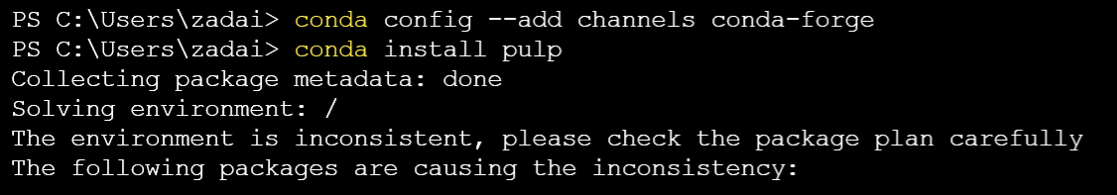

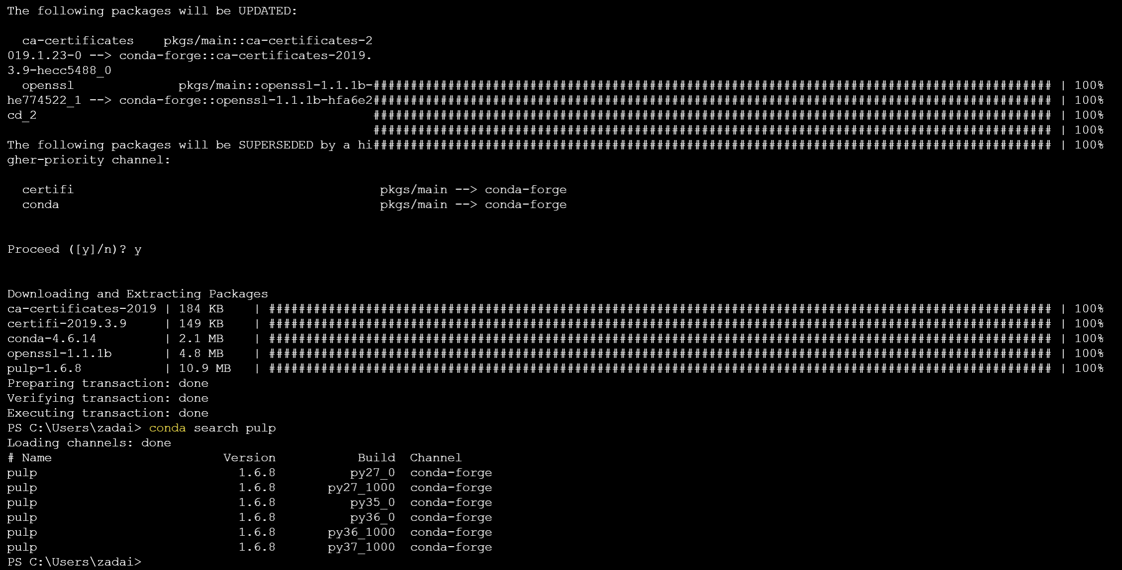

First I needed to search and find the necessary channels to bring in pulp, and once I did that I was finally able to install pulp. Now I can get started on all the steps.

## Step 1: Import PuLP

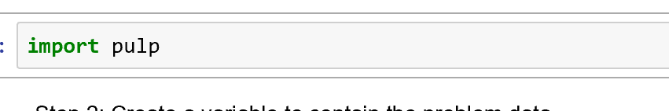

Now we have the necessary package to do integer programming.

## Step 2: Create a variable to contain the problem data



This created the sales variable and will contain our problem data that we will work with throughout the assignment.

## Step 3: Create the two variables needed with a lower limit of zero and an upper bound of none

## 

This creates the i and j variables, i is for phone sales and j is for direct sales.

## Step 4: Add the objective function (dollar collected) to the ‘sales’ variable, then enter the constraints (time)

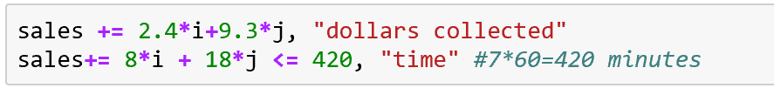

Here based on our two variables we set up the calculations for dollars collected over a 7 hour span or 420 minutes.

## Step 5: The data is written to an .lp file

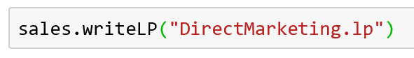

This writes the data into an .lp file.

## Step 6: Solve the problem using PuLP’s choice of solver

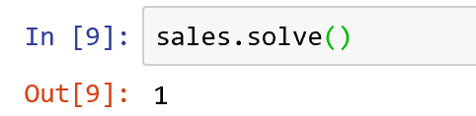

This uses PuLP’s choice of solver to solve the sales problem above.

## Step 7: View the status of the solution – result will be “Optimal”, “Not Solved”, “Infeasible”, “Unbounded”, or “Optimal”

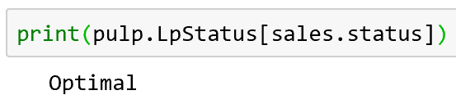

The sales status we ended up printing out is Optimal, which is an ideal status.

## Step 8: View each variables optimum value

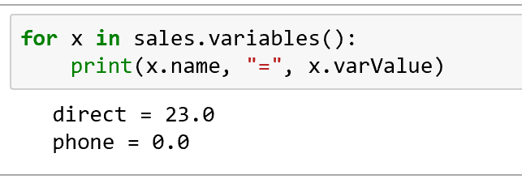

This states how many sales we got from each mode of sales, 23 direct sales and 0 phone sales.

## Step 9: View the optimized objective function

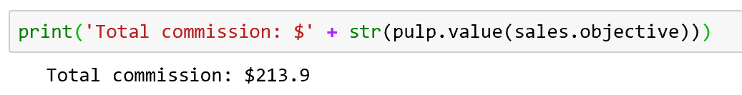

The amount of total dollars made from sales is $213.90. Which truly only came from direct sales because, unfortunately no sales were made from the phone.

## Step 10: What would time spent on the phones need to be reduced to in order to make it an option?

How we can solve this problem is by shortening the time on the phone until at least one phone sale is made, this can be done by creating a small for loop. In this problem everything is kept the same except the time spent on the phone is now 5.

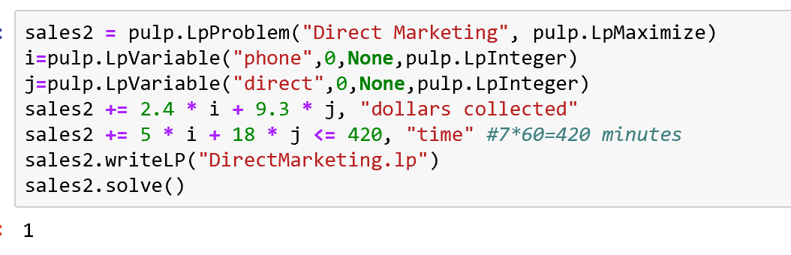

The output of 1 means that our function still works. Which also means we can print out the status of our new sales function too to see what that is.

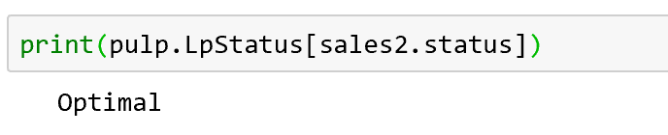

The status of sales 2 is Optimal, just like the original sales function. Now we will implement the for loop.

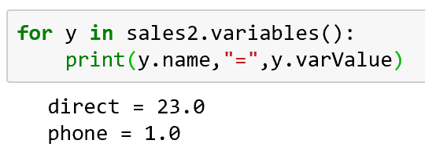

Here we got the desired result that we wanted. We got our 1 phone sale and got 23 sales through the direct method.

Now we print out to see the total dollar amount.

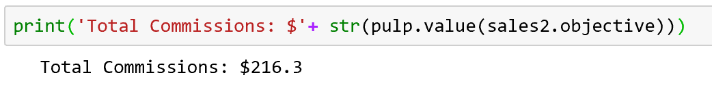

The total sales this time was $216.30, which is a little more than $2 more than the first sales function.

## Step 11: What if everything is kept constant except for the phone success rate? It is changed from 5% to 7%

Here were going to make our third sales function, but this time were going to change the sales success rate to 7%.

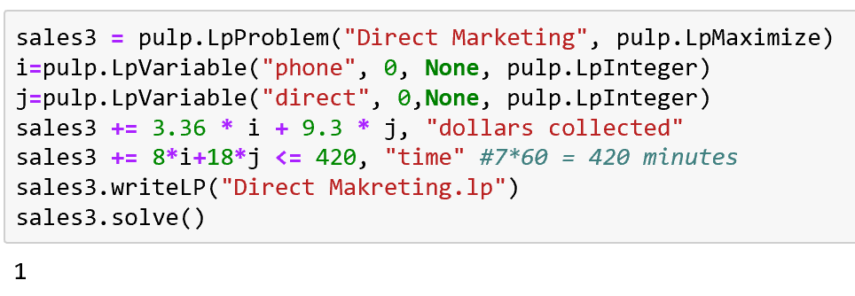

Once again it looks like our third function checks out with the output of 1. Now lets check the status of sales3.

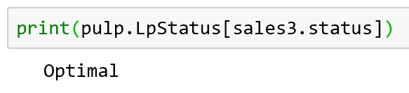

The print status of sales3 returned as Optimal just like the first two functions.

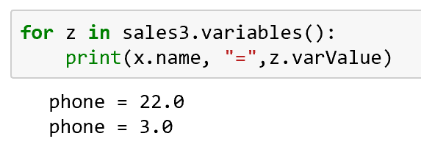

From the for loop we can see that there were 22 direct sales and 3 phone sales.

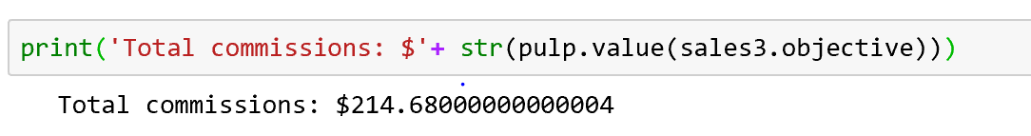

The total dollar amount of the third function is $214.68 which is less than function 2 in total dollar amounts but a little more than the first sales function.

## Summary

In this assignment I got my first crack at using inter programming in python and I found it to be very interesting. I think the use of using functions and assigning variables to create models is a good way to project what kind of numbers you should see if the certain variables that you are interested in reach a specific level, and see that effect on your data. For example, in the assignment we change up certain things about our original model on two occasions and both time get a higher volume of dollars in sales as a result. Seeing this work in action gives me some ideas of how I can use this in my own profession as a data analyst for a healthcare organization. It can be used in billing to make sure we are billing patients properly, or it can be used to possibly understand what certain measures must be at to equate to a patient coming down with a specific type of illness or disease, and then testing that model for accuracy would be fun to try against some real world data.